

[**Mostafa Edrees**](https://www.learn-in-depth.com/online-diploma/mostafaedrees018@gmail.com)

 **GitHub** **Drive**

August 1, 2023

Learn-in-depth



Table of Contents

Problem Statement 2

Student Structure 2

Database Structure 2

2

Functions 3

Functions Prototypes 3

Student Database initialize 3

Add the student details manually. 4

5

Add the student details from text file 5

Find student details by ID number 7

Find student details by first name 8

Find student details by course ID 9

Find the total number of students 10

Delete student details by ID number 11

12

Delete all students 12

Update student details by ID number 13

14

Show all information 15

Additional Functions 16

Show student information 16

Student database is full 16

Check student ID 16

Main 17

Student Database.h 19

Student Database.txt 20

# Problem Statement

Write a program to build a simple software for Student Information Management System which can perform the following operations:

* Store first name of the student.
* Store last name of the student.
* Store unique id number for each student.
* Store GPA for each student.
* Store courses registered by the student.

## Student Structure

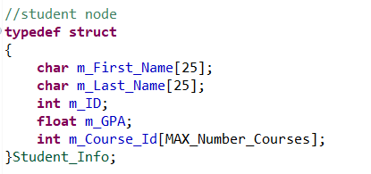

## Database Structure

# 

# Functions

There are 11 options for the student to use it to handle his information.

* Add The Student Details Manually.
* Add The Student Details From Text File.
* Find Student Details by ID Number.
* Find Student Details by First Name.
* Find Student Details by Course ID.
* Find the Total Number of Students.
* Delete Student Details by ID Number.
* Delete All Students.
* Update Student Details by ID Number.
* Show All Information.
* Exit.

## Functions Prototypes

## Student Database initialize

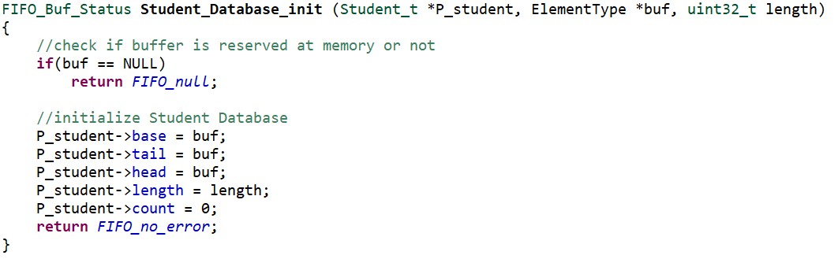

## Add the student details manually.

It’s used to get data from the user and check if the ID number entered by user is unique or not if we find that ID is unique then we add a student to the Database.

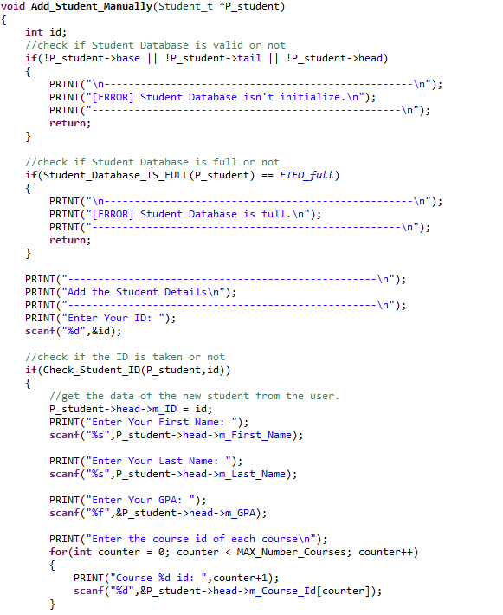

## 

## Add the student details from text file

It’s used to get data from a text file and check if the ID number is unique or not if we find that ID is unique then we add a student to the Database.

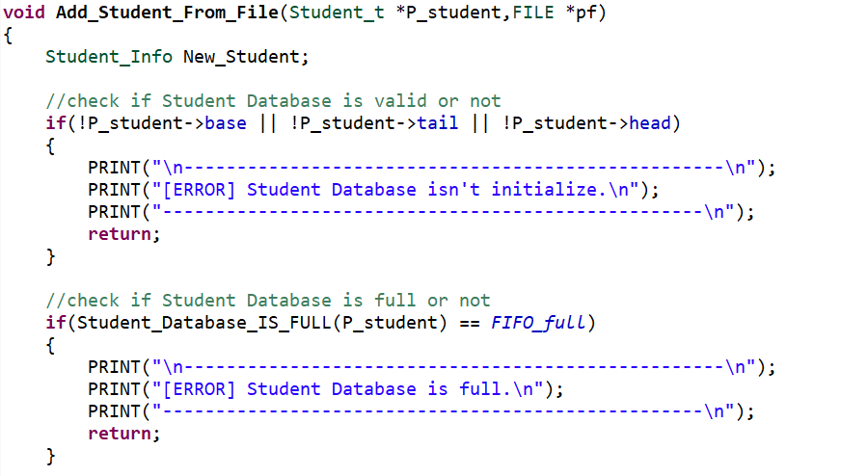

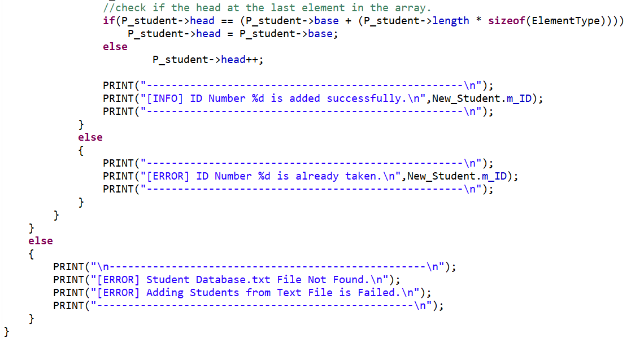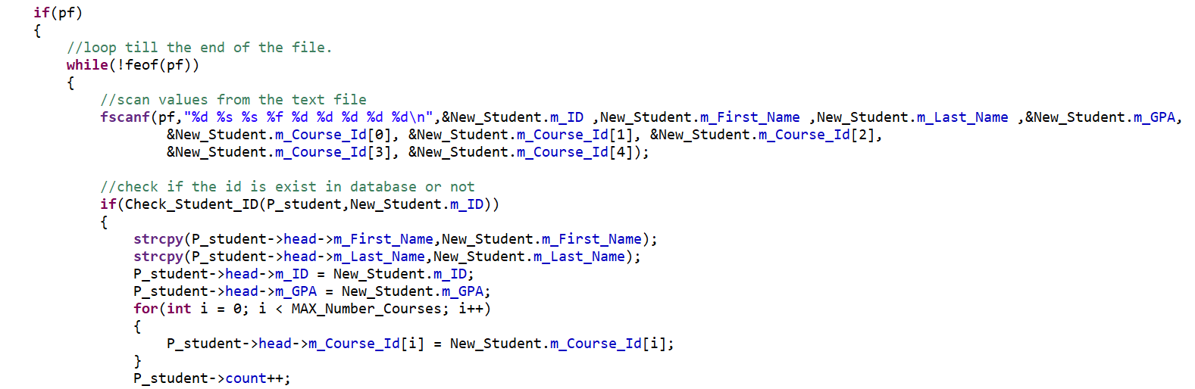

## Find student details by ID number

It’s used to get the student details from database by its own id.

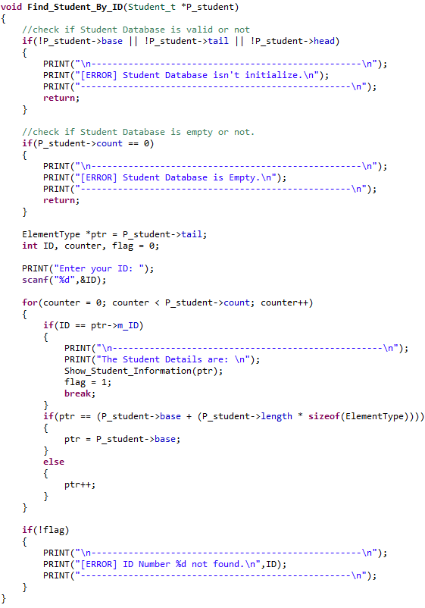

## Find student details by first name

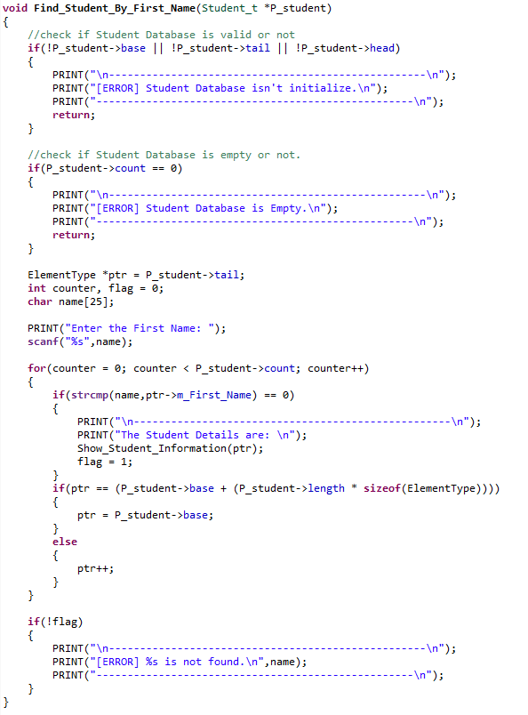It’s used to get student details by its own first name.

## Find student details by course ID

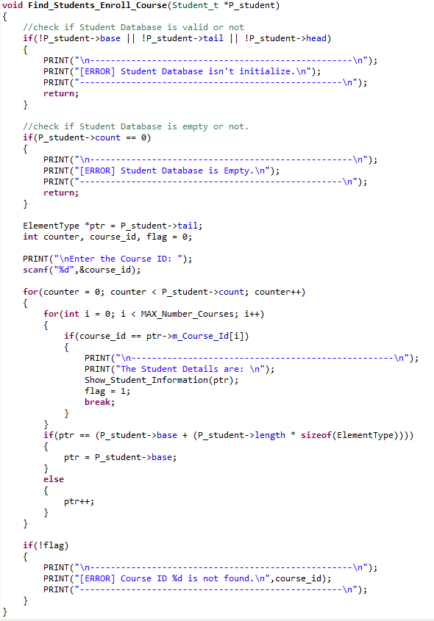It’s used to get the students registered in specific course.

## Find the total number of students

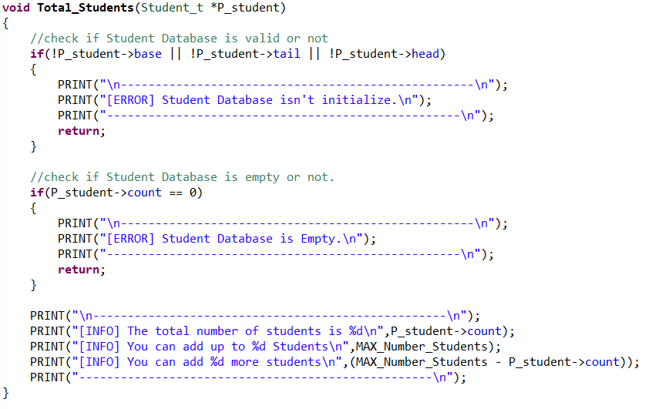It’s used to get the total number of students in the database.

## Delete student details by ID number

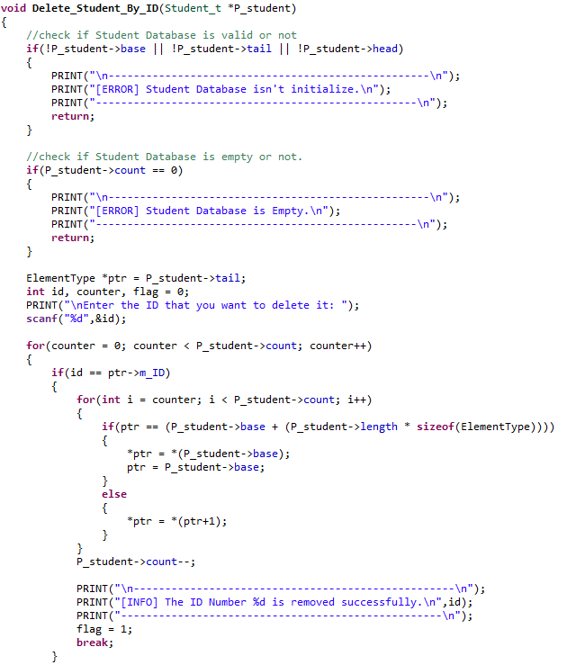It’s used to delete a student from database with its own id.

## 

## Delete all students

It’s used to delete all the students in the database.

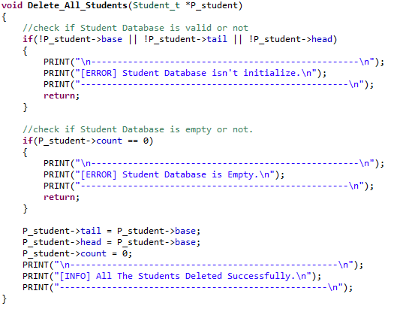

## Update student details by ID number

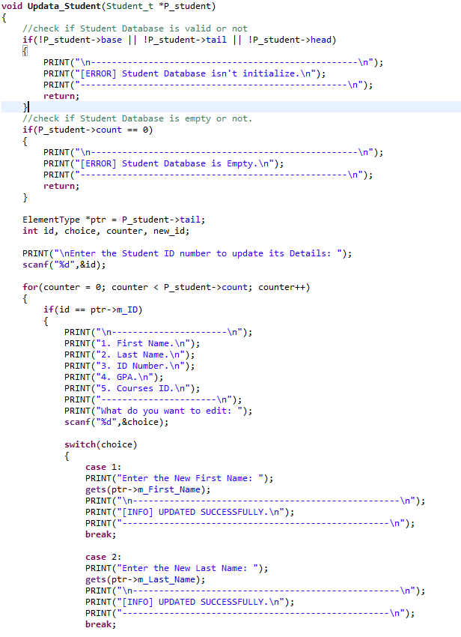It’s used to update the details of any student in the database.

## 

## Show all information

It’s used to show all details of the students in the database.

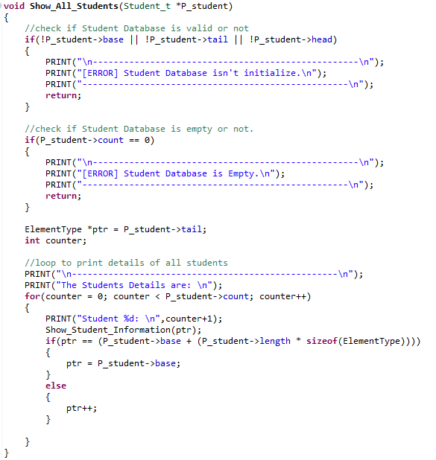

# Additional Functions

## Show student information

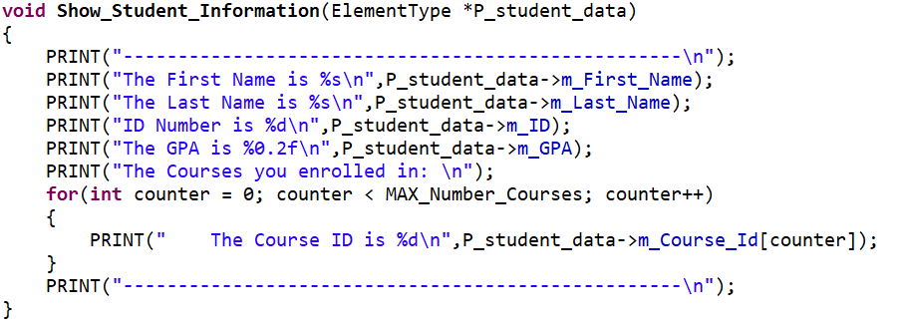It’s used to print the details of the student.

## Student database is full

It’s used to check if the database if full or not.

## Check student ID

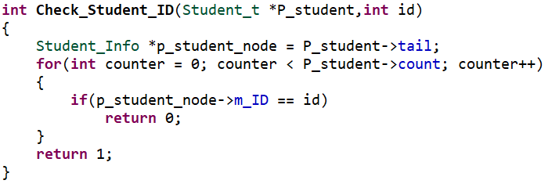It’s used to check the student Id that is unique or not.

# Main

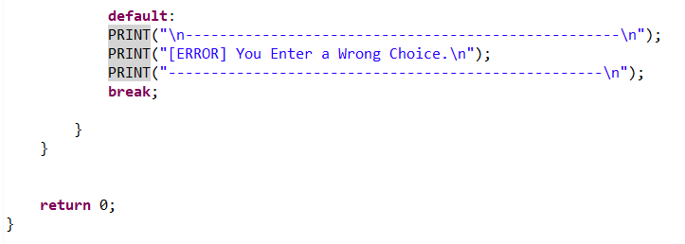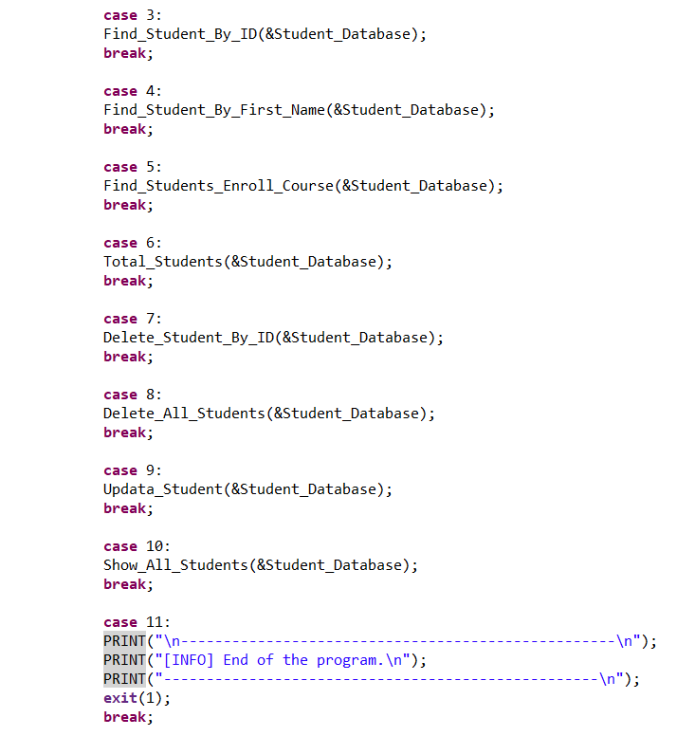

# Student Database.h

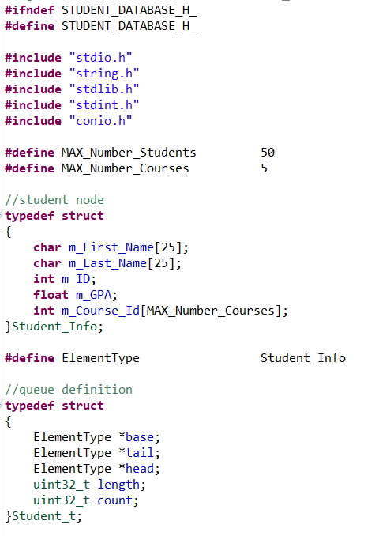

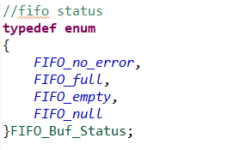

# Student Database.txt

